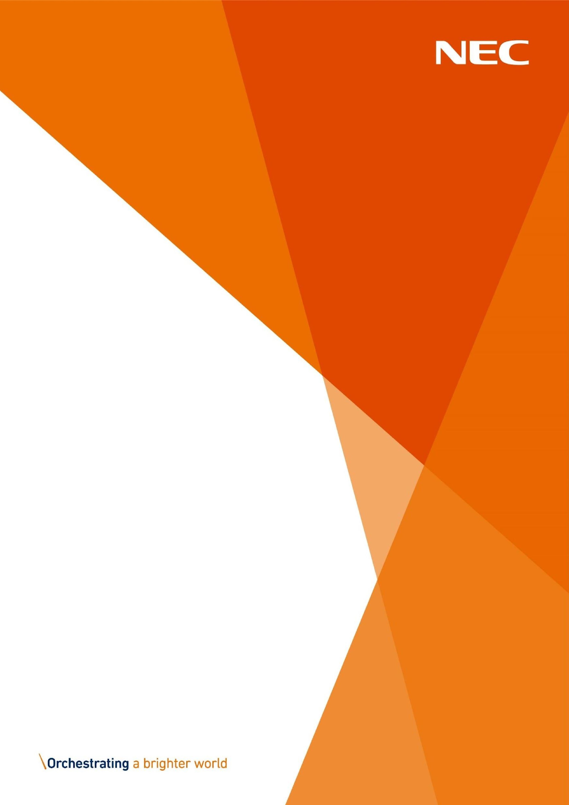
Discretionary Assistance
Fund (DAF) Approved
Partner Bulletin Part 2

March

2026
NECSWS.COM

Further Update

Following the recent spike in oil prices, off grid oil payments will be increasing to £750 a maximum of 2 payments in a rolling 12-month period, with a gap of 3 months in between each application.
Please be reminded that all off grid oil applications must be submitted by an Approved Partner, and the applicant should not have any savings.

If you’re supporting an applicant who has already received 3 EAP’s but requires this support, please call the DAF office on 0800 859 5924 to submit a telephone application for heating oil ONLY. Any applicants that have not received their 3 in 12 will still need to be submitted online.

There are no other changes to the maximum of 3 EAP awards.

Written Statement: Support available to help with the cost of living (18 March 2026) | GOV.WALES

Any queries regarding this please contact Charlotte Perry Partnership and Engagement Manager @ DAF.Partners@necsws.com.


Approved Partner Bulletin



